**Network Task**

**Task Description:**

1.Get me the IP address of a particular domain (guvi.in). How do I find my CPU/memory usage of my server?. Test the connectivity between 2 nodes?

2.I have deployed an application in guvi.com:9000, and logs show my app is running, but I’m unable to view the page. Check whether my port is open or not ?

**Solution : 1**

**✅ 1. Get the IP address of the domain guvi.in :**

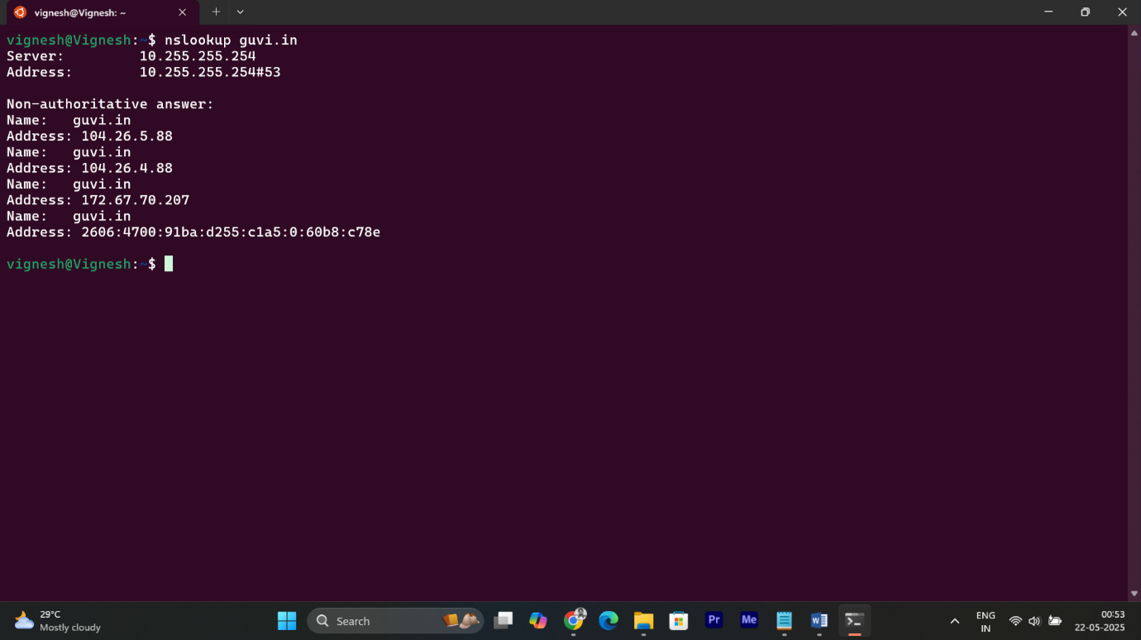

* **nslookup** queries the DNS to resolve the domain name to an IP address.
* Mention that the **IP addresses** (e.g., 104.26.5.88, 104.26.4.88,172.67.70.207) were resolved using DNS lookup.

**✅ 2. Check CPU and Memory Usage of the Server:**

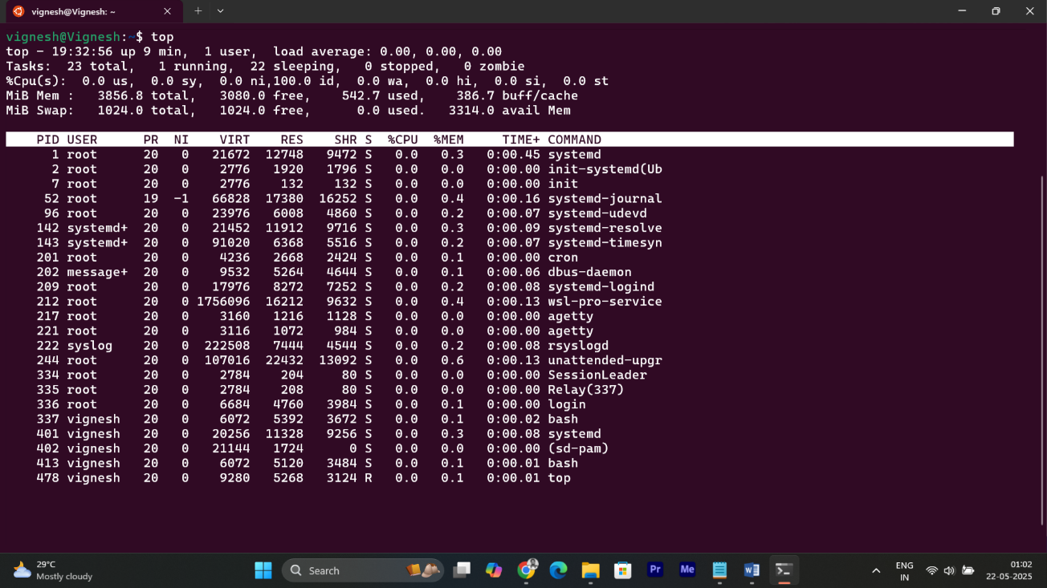

* **top** provides a real-time, interactive view of system processes, including **CPU** and **Memory** usage per process. The **%CPU** column shows CPU usage, and **%MEM** shows memory usage.

**✅ 3. Test Connectivity Between Two Nodes:**

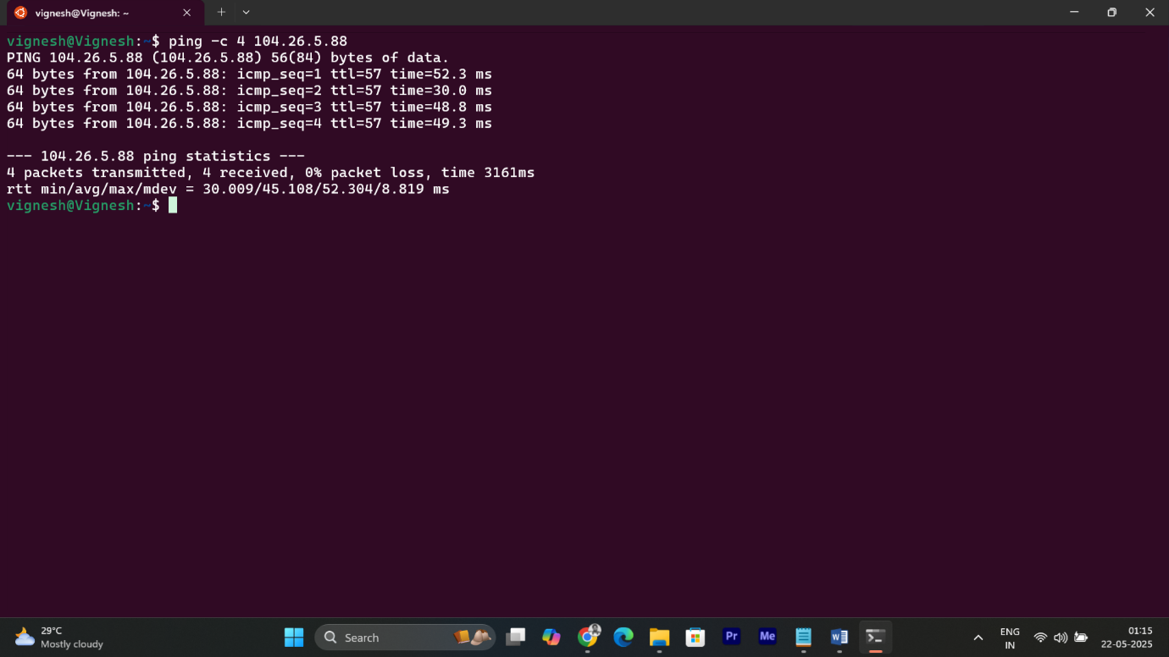

* **ping -c 4 104.26.5.88** (The IP address is associated with the domain guvi.in) sends 4 **ICMP** (Internet Control Message Protocol) packets to the destination IP to test reachability and measure latency.
* **ping** (Packet Internet Groper) checks if a remote host is reachable over a network and measures the round-trip time (latency) for packets sent to it.

**Solution : 2**

**✅ 1. Check if Port 9000 is Open for guvi.com:9000:**

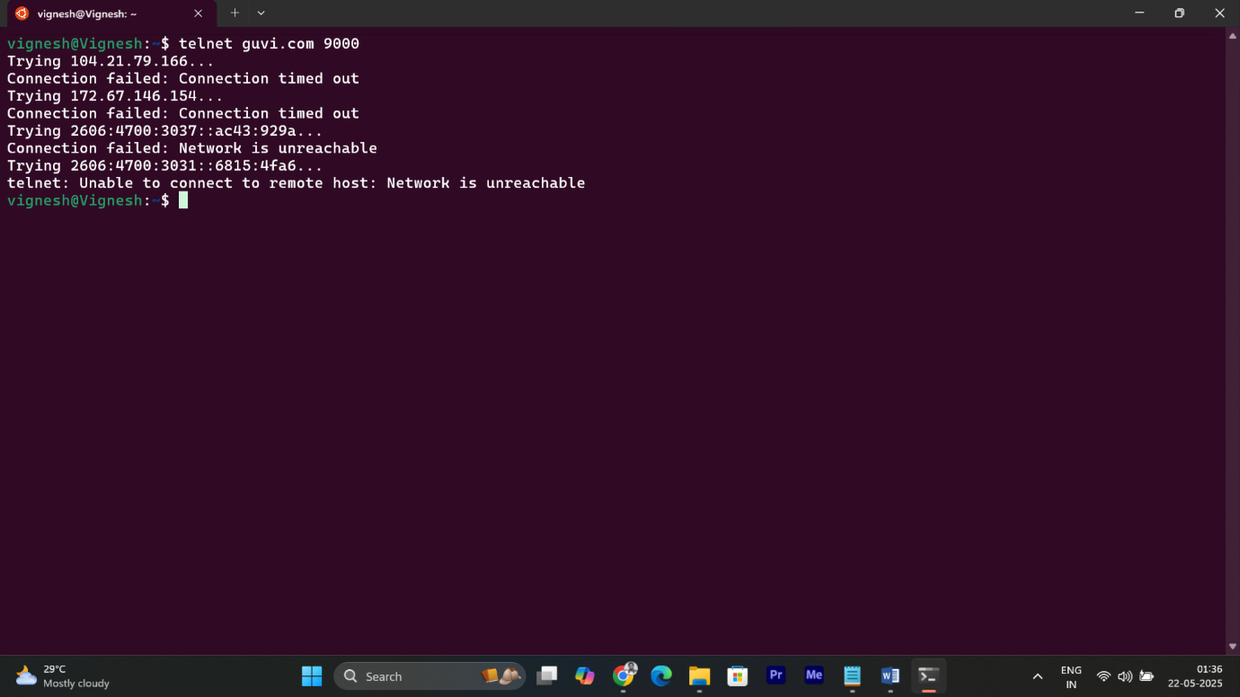

* The domain is reachable (DNS is resolved).
* But **port 9000 is closed**, or the firewall is **blocking** the connection.
* **telnet** used to connect to remote systems over a specified IP address (or domain) and port.It helps test if a specific port is open and accepting connections.